Mock server in postman

You can create mock servers in Postman to help with API development and testing. A mock server simulates a real API server by accepting requests and returning responses. By adding a mock server to your collection and adding examples to your requests, you can simulate the behavior of a real API.

A mock server serves as a simulated or pseudo server that mimics authentic server behaviour. They return controlled responses to requests, letting you design and create JSON API responses without writing a single line of code.

# Steps to create a mock server in postman

1. Open the postman application on your computer then click on the mock servers tab on the left side navigation bar.

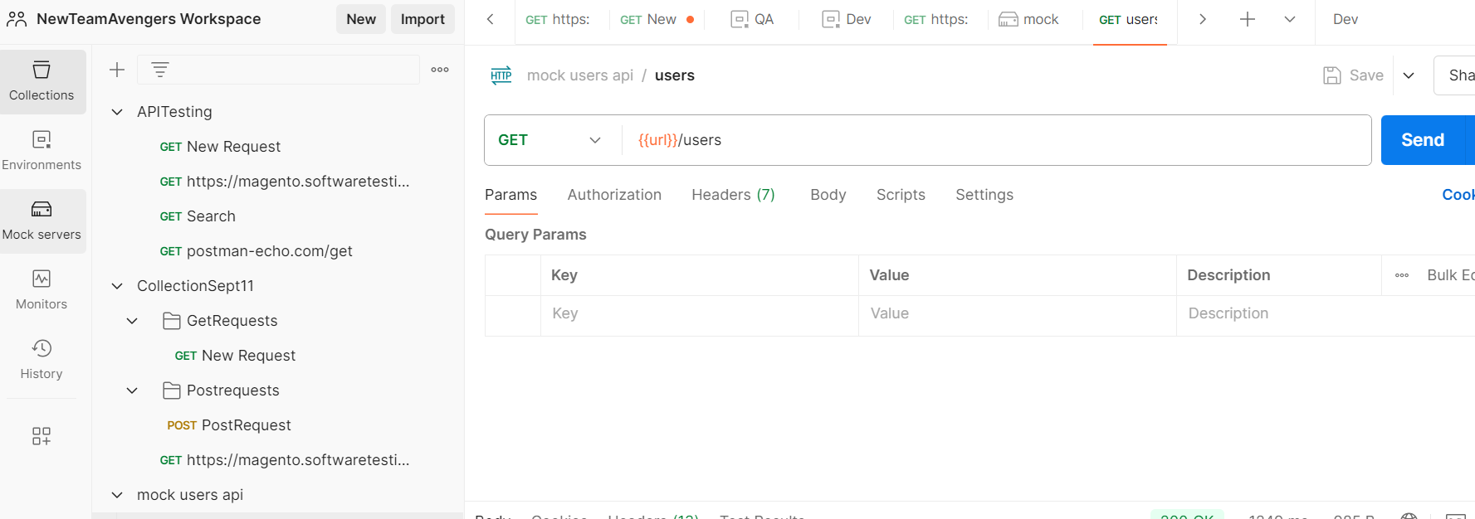



Note- If the Mock server is not visible, then click on the Configure workspace sidebar and select mock server.

1. To create a new mock server, click on the **create mock server**or the plus symbol beside the collections tab.
2. Set the request url input field to **users.**
3. Copy JSON response below and paste in the response body.

[{

"id" : 1,

"name" : "Peter parker",

"username" : "Peter",

"email" : "Peterparker@yopmail.com",

"address" : {

"street" : "Street123",

"suite" : "Apt. 556",

"city" : "San Jose",

"zipcode" : "92998-3874"

},

"phone" : "1-770-736-8031"

},

{

"id" : 2,

"name" : "Emma Mathew",

"username" : "Emma",

"email" : "EmmaMathew@yopmail.com",

"address" : {

"street" : "Street111",

"suite" : "Suite 123",

"city" : "Boston",

"zipcode" : "90566-7771"

},

"phone" : "010-692-6593"

}]

1. Click on Next
2. Within the configuration tab, we will set the mock server name.
3. Select the Save the mock server URL as an environment variable checkbox.
4. Click on the Create Mock server button on your bottom right.

## Testing the mock server

Navigate to the collections tab, then click on the mock server apicollection which was created and select **users**.

Run the API and check the response.

# Mocking an existing collection

In Postman, mock servers rely on examples saved in an HTTP collection to return mock data.

## Steps to create examples

1. Create an HTTP GET request
2. Click on Send
3. Save the request to a collection
4. Save the response as an example by clicking on the example option

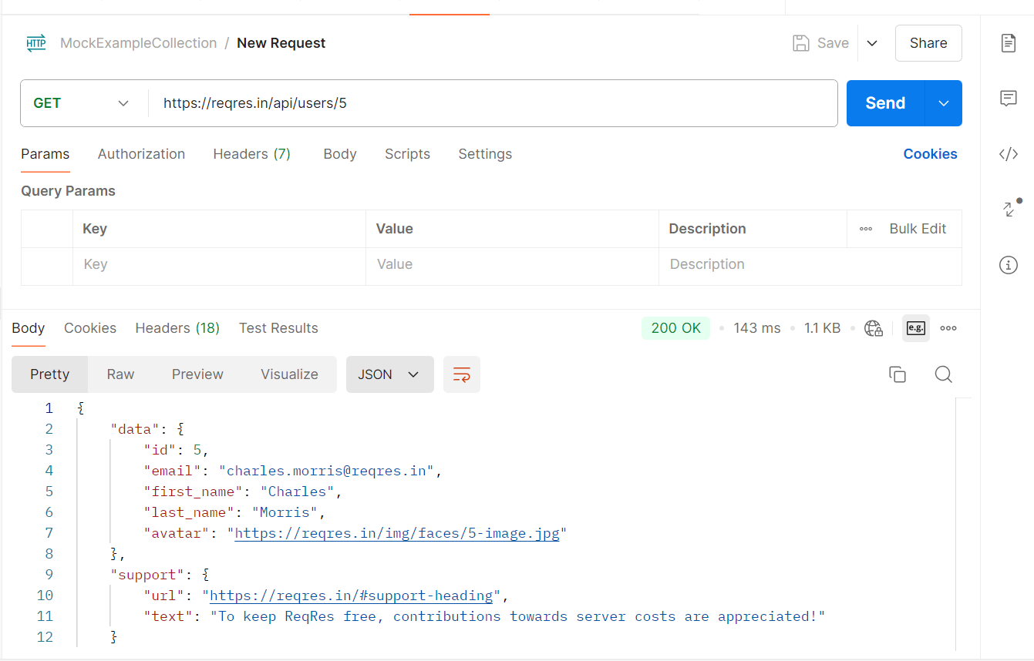



To rename the example, select the example name and rename the example

## Creating mock server for the collection and using example to mock the response

To create a mock server for the collection, do the following:

1. Select **Collections** in the sidebar.
2. Select the more actions icon More actions icon next to the C1 collection, and then select **Mock collection**.

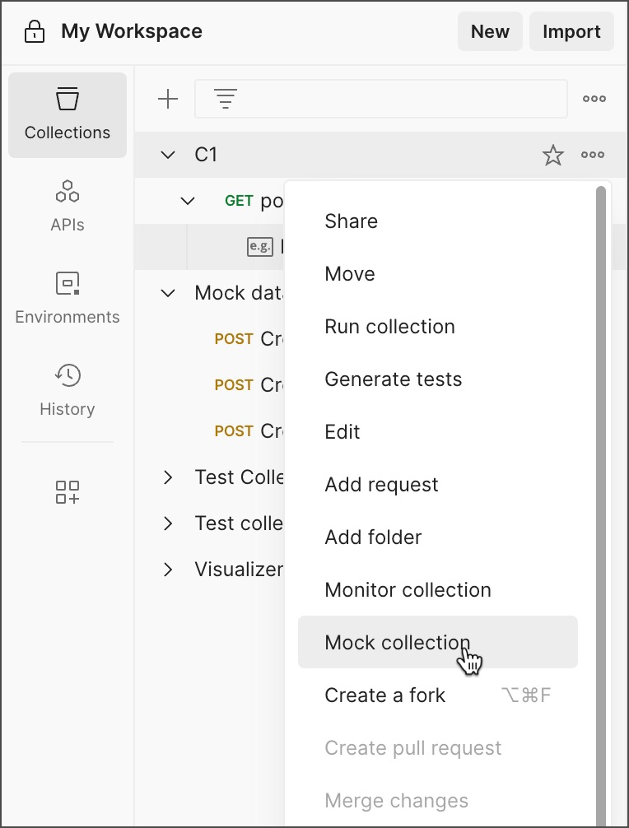

1. Enter mock server name and click on create Mock Server
2. Copy the mock URL
3. Create a new request by selecting New > HTTP, or selecting + to open a new tab.
4. Paste the mock URL as the request URL, then select Send.

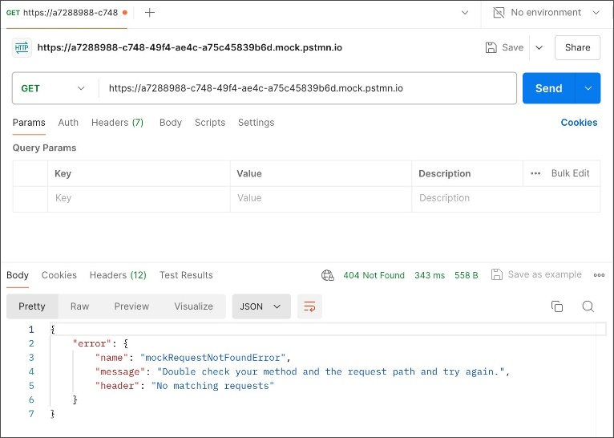

1. The request returns an error because the mock server URL doesn't have a path appended to the end. The path appended to the end of the mock server URL must match the path in the example's request URL
2. To successfully send a request to the mock server, add path to the end of the mock server URL and select **Send**.

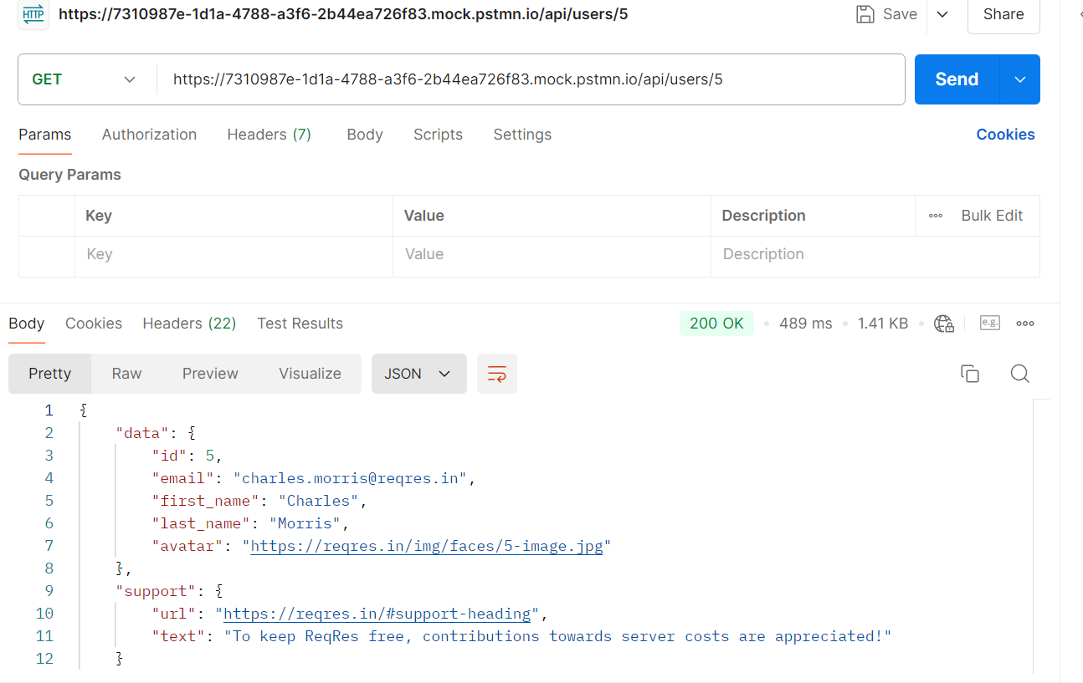

1. We can add multiple examples for different response and validate the data

# Mock server usage

Postman plan gives you a limited number of requests that can be sent to your Postman mock servers each month. Requests to all of your mock servers count toward this same limit. After the limit is reached, you will get a Usage limit reached error message in the response body when sending a request to one of your mock servers.

In freeplan, 1000 requests are allowed per month

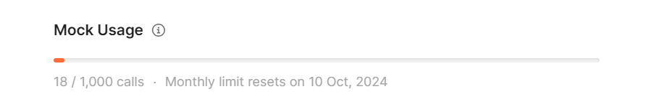

billing/add-ons/overview

